|  |
| --- |
|  |
| Capstone Project Document |

**First Aid Viet Nam**

Report #6 – User Guide

|  |  |  |
| --- | --- | --- |
| **Dandelion** | | |
| **Group Members** | Nguyễn Phúc An | SE02585 |
| Đàm Huy Hùng | SE02619 |
| Nguyễn Duy Anh | SE02723 |
| Mai Trung Kiên | SE02700 |
| Nguyễn Tiến Dũng | SE02967 |
| **Supervisor** | Mr. Nguyễn Văn Sang | |
| **Project code** | FAVN | |

**- Hanoi, 12/2015 -**

# SIGNATURE PAGE

AUTHOR: Nguyễn Phúc An 07/12/2015

Team member

REVIEWERS: Đàm Huy Hùng 12/12/2015

Project manager

APPROVAL: Nguyễn Văn Sang --/--/--15

Supervisor

Record of change

*A - Added M - Modified D – Deleted

|  |  |  |  |  |  |
| --- | --- | --- | --- | --- | --- |
| Effective Date | Changed Item | A,M,D | Change Description | Reason for Change | Rev. Number |
| 07/Dec/2015 | User installation | A | Add new |  | 1.0 |
| 10/Dec/2015 | User guide | A | Add new |  | 1.0 |
|  |  |  |  |  |  |
|  |  |  |  |  |  |
|  |  |  |  |  |  |
|  |  |  |  |  |  |
|  |  |  |  |  |  |
|  |  |  |  |  |  |
|  |  |  |  |  |  |
|  |  |  |  |  |  |
|  |  |  |  |  |  |
|  |  |  |  |  |  |
|  |  |  |  |  |  |
|  |  |  |  |  |  |
|  |  |  |  |  |  |
|  |  |  |  |  |  |
|  |  |  |  |  |  |

Table of Contents

SIGNATURE PAGE 1

1 Introduction 3

2 USER GUIDELINES 3

2.1 First Aid 3

2.2 Ambulance 16

2.3 Admin 18

2.4 Dispatcher 19

# Introduction

This user's manual has been developed to help users better understand the requirements that may apply to use this website by providing them simple step by step tutorials. This manual is intended to help make website's functions more accessible and their associated requirements more understandable to users.

# USER GUIDELINES

## First Aid

This is the first screen which user will see. From this screen the user can go to every screen they want to use features.

To use this application, the users do the steps below:

Step 1: Download and install application

Step 2: Launch application

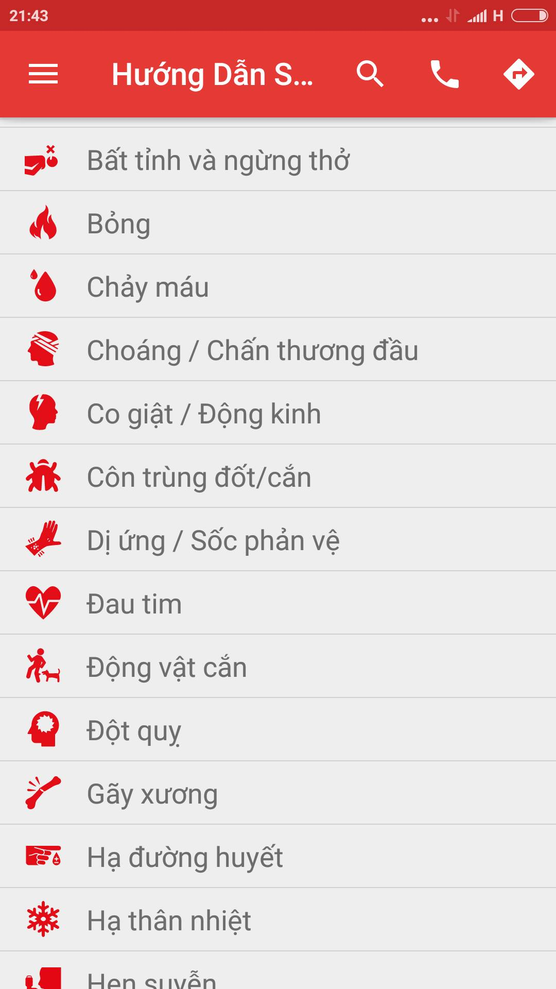

1. Hướng dẫn sơ cứu screen

### Emergency Details

To see the details of emergency, users do the steps below:

Step 1: Launch application

Step 2: Tap on one random emergency case

Step 3: Screen displayed the details of emergency case

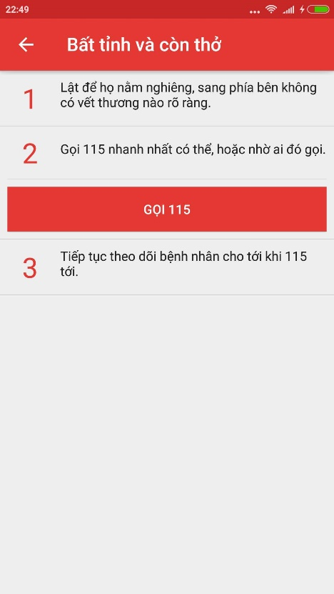

### Search emergency case

To search emergency case, the users do the steps below:

Step 1: Launch application

Step 2: Click on button search of “Hướng dẫn sơ cứu” screen

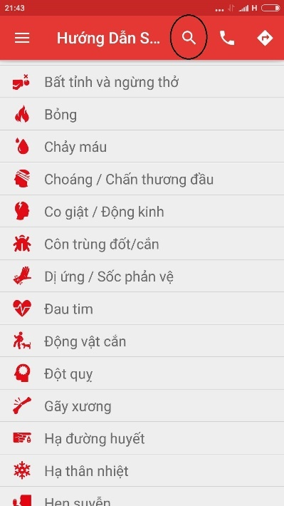

**Figure 2-2.1: Search Screen**

Step 3: Input the characters you want to search in textfield

Step 4: Screen display the result

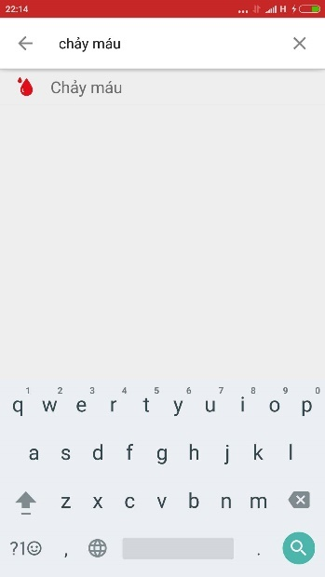

1. Search result screen

### Call 115

To use Call 115 function on this application, the users do the steps below:

Step 1: In “Hướng dẫn sơ cứu” screen, tap on icon “Call”

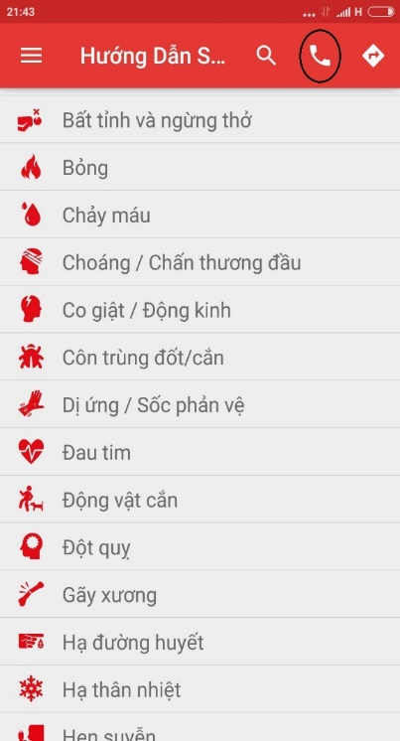

**Figure 2.3.1: Icon Call**

Step 2: Call 115 screen is displayed

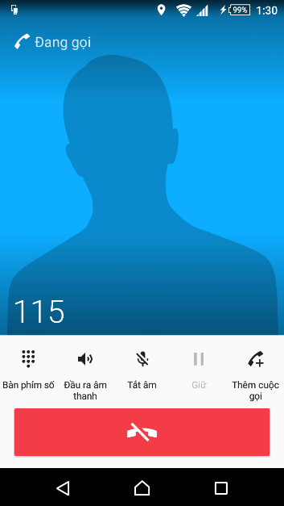

Figure 2.3.2 Search project

### Direct

In this function, user can know about current position, 20 nearest health facilities, direct from current position to selected health facility.

Step 1: Launch Application

Step 2: Click on icon direct

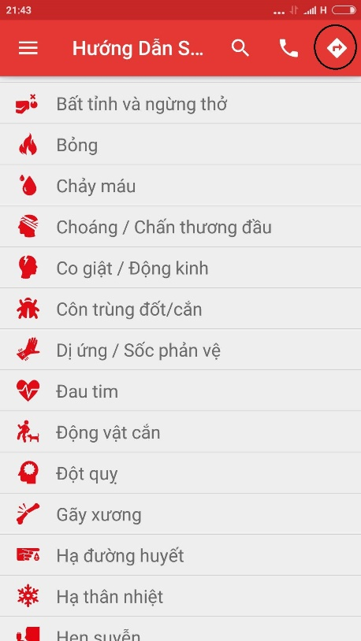

**Figure 2.4.1: Icon direct**

Step 3: Screen displayed map and current position, tap on button “Cơ sở y tế gần đây” to see the list of nearest health facilities

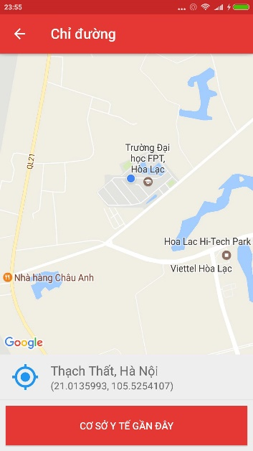

Step 4: Select one of health facilities list (figure....) , then tap on button direct ( figure ..... )

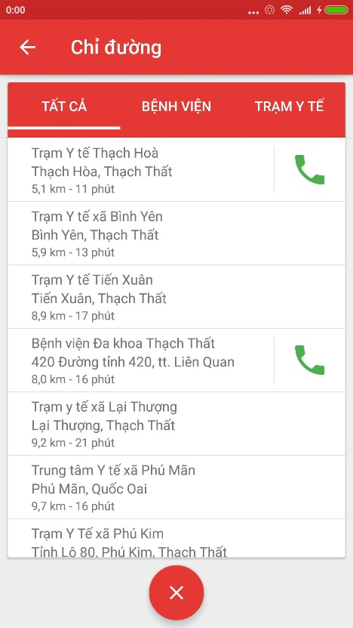 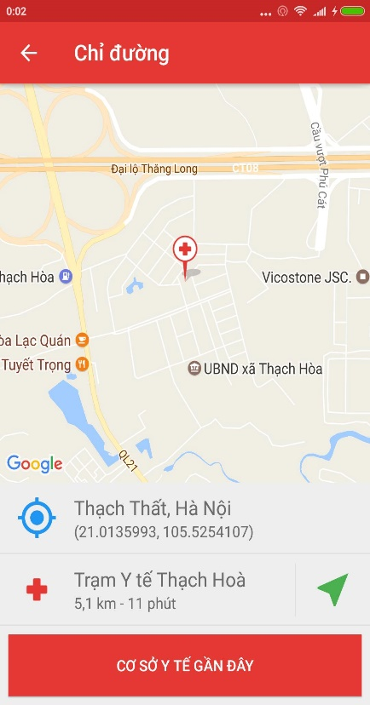 Figure: Figure:

Step 5: Tap on button direct, screen show the direct from current postion to the selected health facility

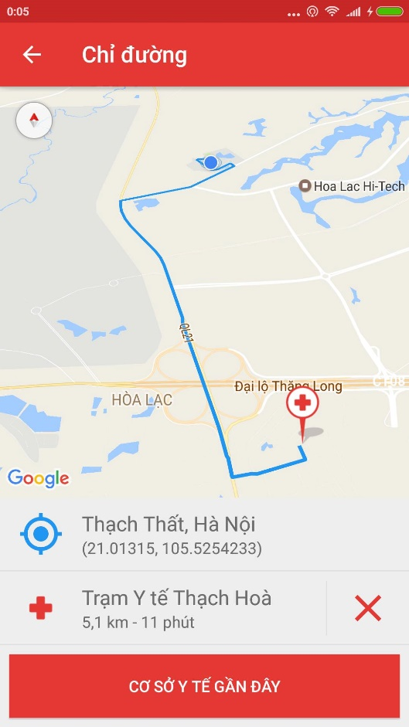

### Learning

In this screen, users can view the detail of learning topic, view the list of câu hỏi thường gặp, can send the question to the system. To use those feature, user do as step belows:

Step 1: Launch application

Step 2: Tap on icon Menu

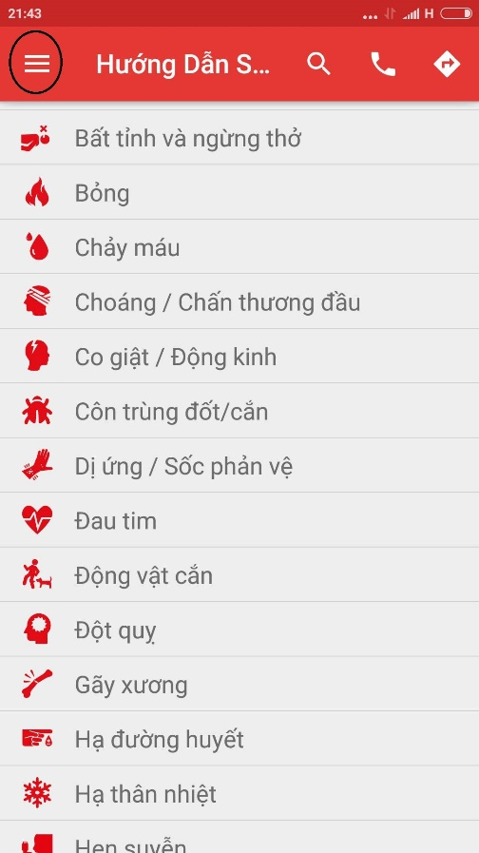

Step 3: Tap on icon Tìm Hiểu

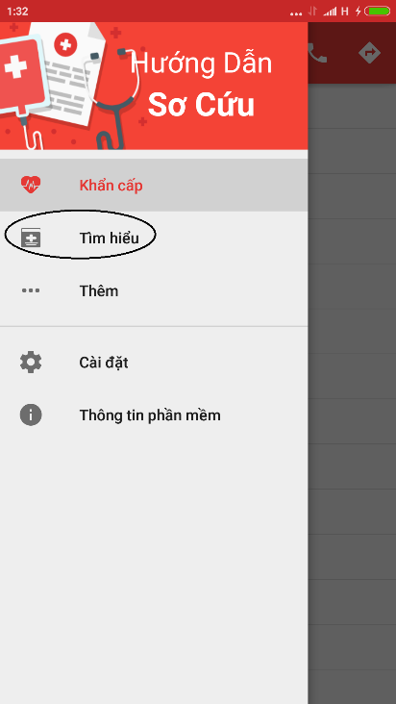

Step 4: Screen displayed list of learning topic ( ảnh)

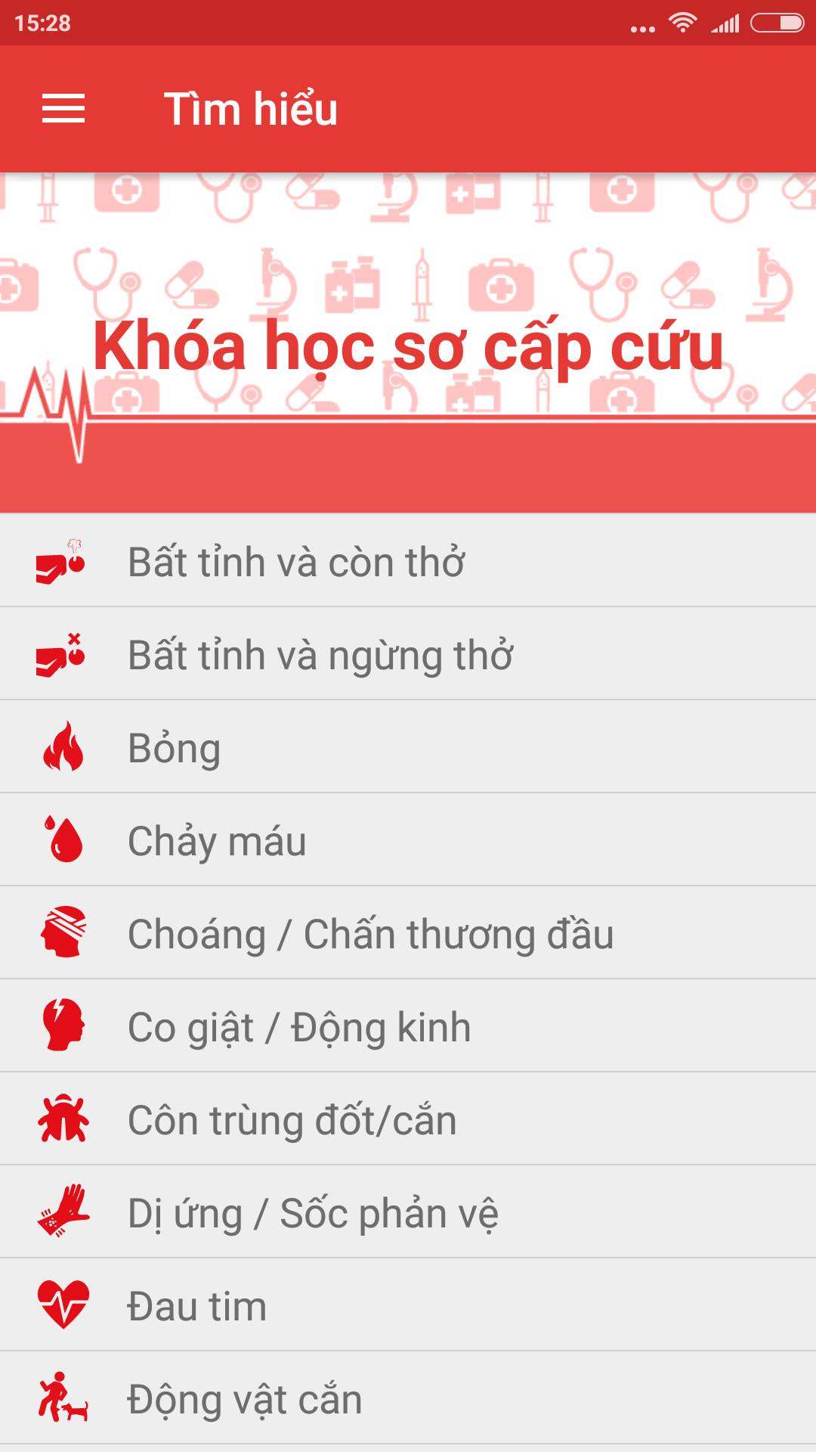

Step 5: Tap on random topic

Step 6: Screen displayed details of selected topic

Step 7 : Tap on button “ Câu hỏi thường gặp” to view the list of FAQ

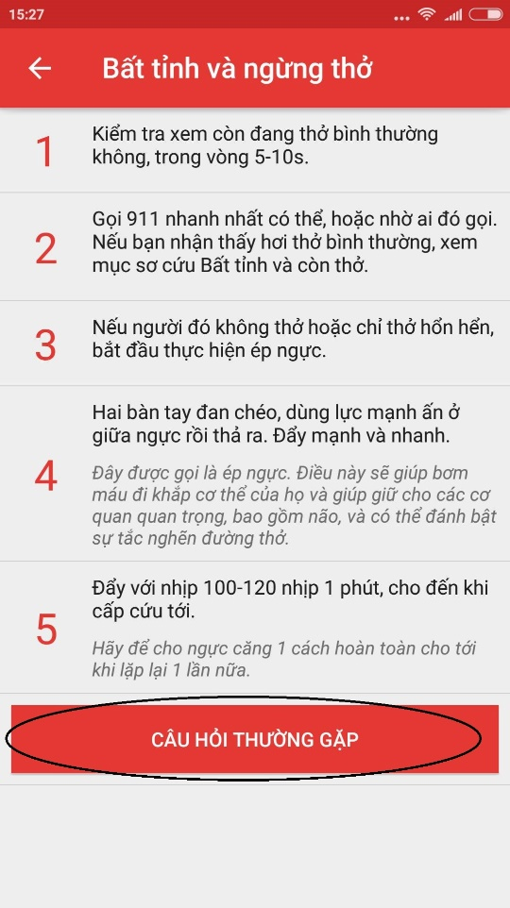

Step 8: Screen displayed list of FAQ

Step 9: Tap on button “ Đặt câu hỏi cho chúng tôi” to send question to system

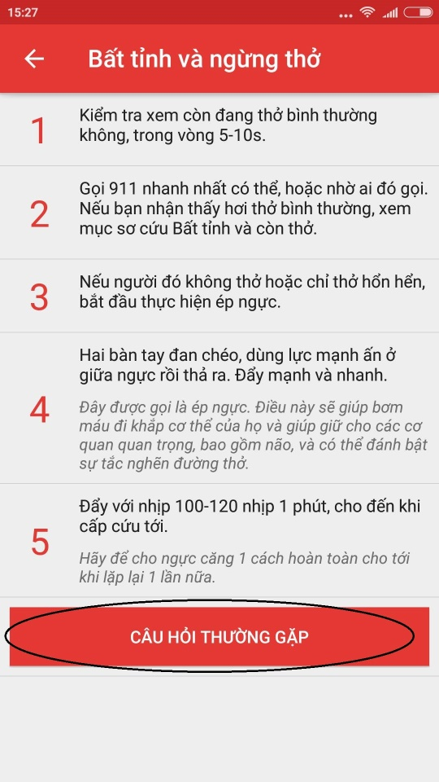

Step 10: Fill all field and tap on button “ Gửi”

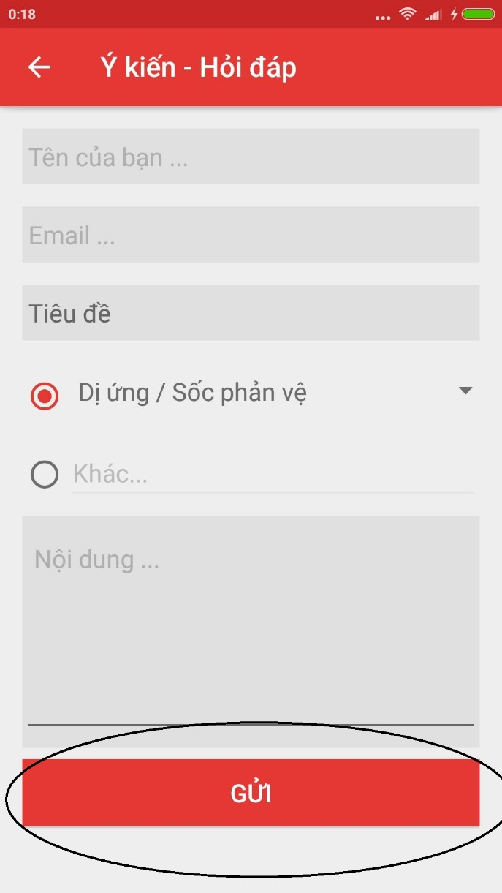

### Setting

In this screen, you can setting to send or not send your location and phone number. To use features in this function, users do the steps below:

Step 1: Launch app

Step 2: Tap on icon Menu and select Setting

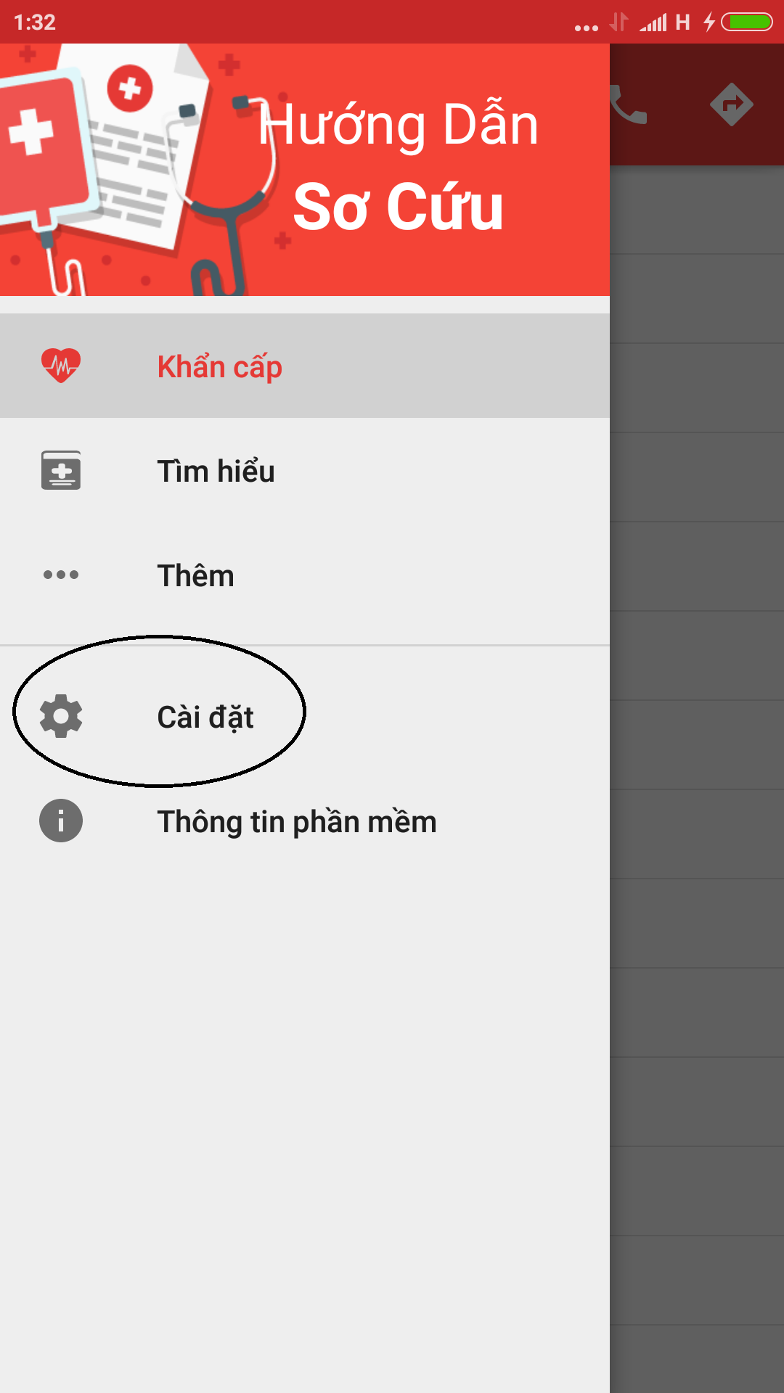

Step 3: If you want to send information, tap on button “Đồng Ý Gửi” (ảnh)

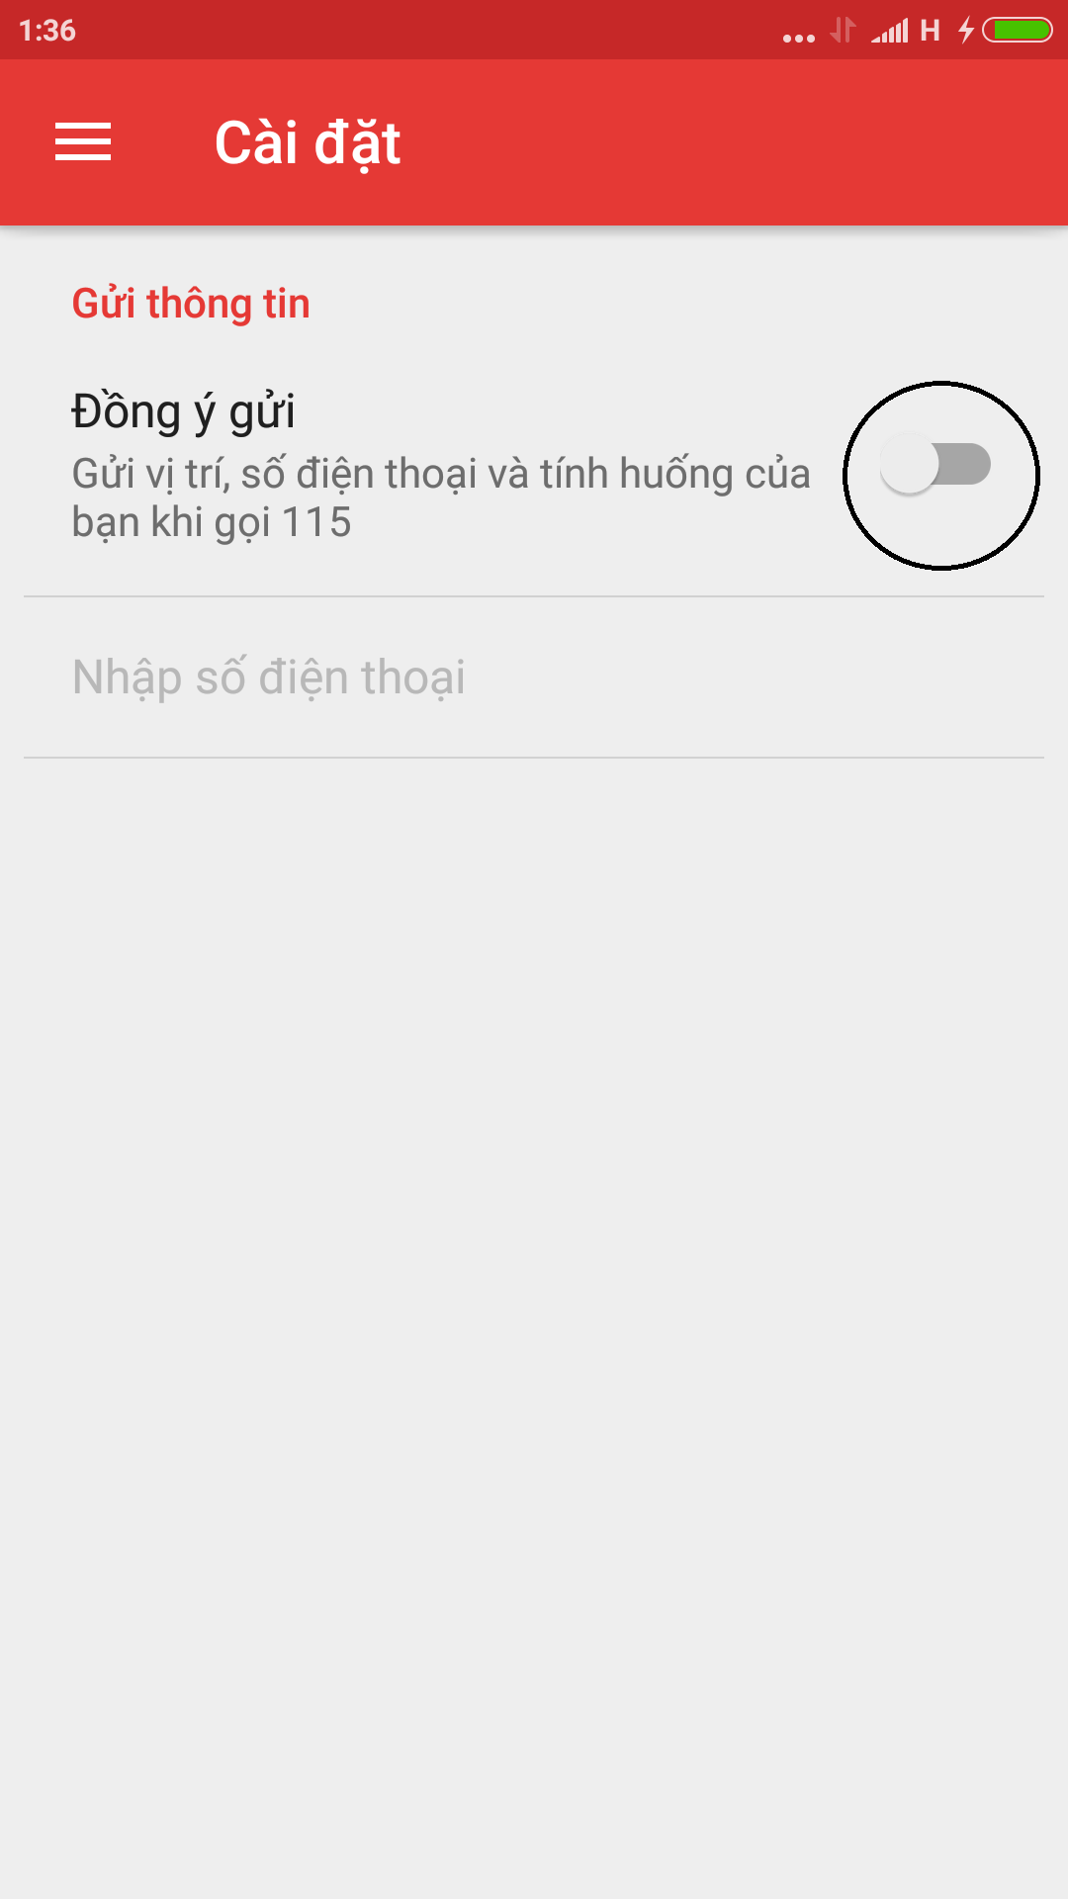

Step 4: Tap on “Nhập số điện thoại” to input your phone number (ảnh)

Step 5: Tap on button OK, your phone number displayed on the screen(Ảnh)

Tap on button Hủy, the dialog is disappears (ảnh)

### Software information

In this screen, you can view the information of software like version, term of use, information of developers.

Step 1: Launch application.

Step 2: Tap on icon Menu then select “Thông Tin Phần Mềm”.

Step 3: Screen displayed information of software.

## Ambulance

This is the first screen which user will see. From this screen the user can go to every screen they want to use features.

Step 1: Download and install application

Step 2: Launch application and login

### Ready/Not ready to take the task

Users depending on their current state can decide to take the task or not

### Software information

To see the information about this application, the users do the steps below: ( ảnh)

Step 1:

Step 2:

### Locate

When users want to locate current location, do the steps below:

Step 1: Login the application and take the task

Step 2: Tap on button “Định Vị” ( ảnh)

When users want to locate current location of victims, do the steps below:

Step 1: Login the application and take the task

Step 2: Tap on icon victim (ảnh)

### Report problem

When users have problem, to report to dispatcher, users do the step below :

Step 1: Tap on button “Báo cáo sự cố”

### Finish the mission

When users want to finish their mission, do the step bellows:

Step 1: Tap on the button Finish

## Admin

In this web application, registered users can add new users with role, edit information of users, delete users, view information of users, classify users by role, search users.

### Login & Logout

#### Login

To use features of this web application, users follow the steps belows :

Step 1: Open browser and enter to the address bar: <http://dandelionvn.com/>. Homepage is displayed

Step 2: Login with the administration account. (ảnh). Users will go to the Home page. In this page, registered users can go to all of other page.

#### Logout

Step 1: On the Home page, click on name of users at the top right of page, then click button “Logout”

Step 2: Users will go to the login page

### Add new users

To add new users, user do the steps belows:

Step 1: Click on button Users on the menu bar at the left of page

Step 2: Click on button Add New Users ( ảnh) , users wil go to the add new users page ( ảnh)

Step 3: Fill validate data on all textfield, then click button Add new user, page will go to the page users, and display messege: “Add new users successfull” ( ảnh)

3.1. To reset data all of all field, click on button reset (ảnh), all field will be default

### Classify users by role

To classify users by role, user do the step below:

Step 1: Click on button Users on the menu bar at the left of page

Step 2: Click on the dropdown list belows label “Classify users by” and choose a role

Step 3: Page will display the list of users classify by role

### Search users

To search users, user do the step below:

Step 1: Click on search textbox (ảnh)

Step 2: Input characters then click on button search

Step 3: Page will display the list of result

### Edit users information

To edit users information, users do the step below:

Step 1: Click on icon Edit (ảnh), page will go to the edit users page

Step 2: Edit information of users

Step 3: Click on button Edit, page will display messege : Edit successfull

3.1. To reset data all of all field, click on button reset (ảnh), all field will be default

### Delete users

To delete users, user do the step belows:

Step 1: Click on icon delete users, a confirm dialog will display

Step 2: Click on button OK, users will be deleted

### Question – Answers.

To use this feature, user do the step belows:

#### Answer the question

Step 1: Click on button “Question- Answers “ on the menu bar at the left of screen

Step 2: Page will go to the page “Question-Answers”, show the list of question (ảnh)

Step 3: Click on icon answers to answers the question, page will be move to answer question

Step 4: After fill all field, click on button send

#### Delete the question

Step 1: Click on button “Question- Answers “ on the menu bar at the left of screen

Step 2: Page will go to the page “Question-Answers”, show the list of question (ảnh)

Step 3: Click on icon delete, a confirm dialog will be display

Step 4: Click on button OK, Question will be deleted

## Dispatcher

In this page user can view messages to create new message, delete message, view message conversation.

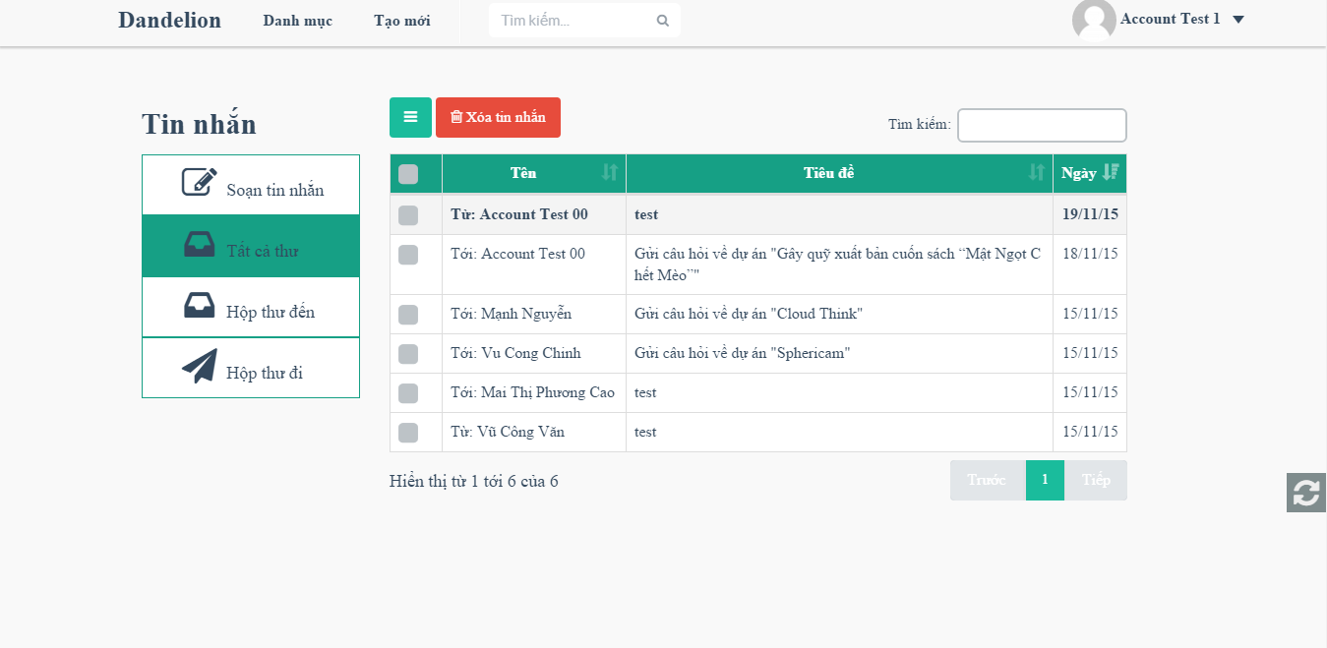

1. Message screen